April 18, 2017

Mr. William Shaw McDermott
Chairman, Board of Directors
Metropolitan Washington Airport Authority
1 Aviation Circle
Washington, D.C. 20001

Dear Mr. Chairman and Members of the MWAA Board:

On behalf of the Board of Directors and more than 1,250 members of the Loudoun County Chamber of Commerce, I write to ask the Board of the Metropolitan Washington Airport Authority (MWAA) to reject a proposal to raise the cost on air travelers using Washington Dulles International and Reagan National airports by artificially hiking the labor costs for airlines and contractors at these airports.

Our Chamber has long been a steadfast supporter of MWAA and its efforts to improve the competitiveness of Dulles International Airport. The Loudoun Chamber was part of a diverse coalition of business stakeholders who successfully lobbied the Virginia General Assembly to provide $50 million to help MWAA restructure its debts and make Dulles International Airport more economically competitive.

Like our fellow Northern Virginia business organizations, the Loudoun County Chamber was proud, on multiple occasions, to stand and fight for the interests of Washington Dulles International Airport, because we recognize the airport’s irreplaceable contributions to our region’s economic health. We believe that forcing MWAA’s contractors to pay higher than market wages for labor undermines the airport’s competitiveness by increasing the cost of flying from Dulles International. For those travelers that use the airport, many of whom are Loudoun County residents and businesses, these increased costs will result in more expensive air fares.

No matter what some may say, the inviolable laws of supply and demand dictate that costs that cannot be passed on in the form of increased fares will ultimately result in reduced services or job losses for the most vulnerable workers.

In addition, I beg that you keep in mind the certain negative impact this move will have on the reputations of Washington’s airports and the communities that support them. Loudoun County has worked extremely hard to refashion our reputation as an outstanding location to do business. Those investments made by our community have paid, and will continue to pay, dividends for all of Loudoun’s stakeholders, including Washington Dulles Airport. A move to artificially raise the cost of doing business in Loudoun County threatens to undermine the value of those investments.

The Virginia business community has stood tall with MWAA fight for our airports and the investments that support them, such as the Dulles Metrorail Project. We ask that you take the wise course of action to reject a move to force your contractors to adopt this ill-conceived wage hike mandate.

Sincerely,

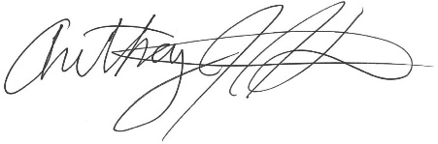
Anthony J. Howard
President & CEO
Loudoun County Chamber of Commerce

